

PROJECT

KRA028
Date: 15th November 2021 Michal Kraninger

Obsah

1. DD S01 L02 3
2. DD S02 L02 4
3. DD S03 L01 11
4. DD S03 L02 14
5. DD S30 L04 15
6. DD S04 L01 16
7. DD S04 L02 17
8. DD S05 L01 24
9. DD S05 L03 25
10. DD S06 L01 25
11. DD S06 L02-04 26
12. DD S07 L01 27
13. DD S07 L02 27
14. DD S07 L03 28
16. DD S09 L02 29
17. DD S10 L01 30
18. DD S10 L02 32
19. DD S11 L01 32
20. DD S11 L02-04 33

DD S01 L02

Vysvětlete rozdíl mezi pojmem data a informace - příklad ve vašem projektu psáno anglicky

Data: Raw material that has not been processed or analyzed.
Information: Knowledge, intelligence, a particular piece of data with a special meaning or function

More examples to illustrate the difference between data and information:
Data: telephone directory (names, addresses, and phone numbers)
Information: names and phone numbers of florists in your neighborhood - a useful subset of the data
Data: details collected on a government population census survey

Information: totals of people in the country grouped by age, occupation, state, or district they live in; useful summary calculations from the data

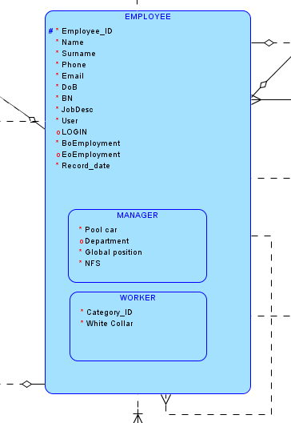

Example from my project:

Data is all attributes of the table Employee:
- employee_id
- name
- surname
- phone
- email
- dob
- BN
- JobDesc
- manager
- "User"
- login
- Boemployment
- Eoemployment
- Record_date

Information is specific pieces of collected data giving us a our required request.

For example:
- How many employees are in the database?
- What is the most frequent name of the employees?
- What is the average age of all of them?
- How many employees started their job in year 2019?
- etc.

DD S02 L02

Entity, instance, atributy a identifikátory - popište v příkladech na vašem projektu

Entities:
- Employee
- Address
- PPEs

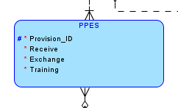
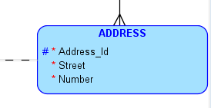

Instances are:

Employee | PPEs | Address
Michal Kraninger | 1 | U Kapličky 1576/1
Markéta Kostková | 2 | U Rybniků 10
Ellen Kacálová | 3 | Dělnická 1132

Attributes:

Employee

Attribute | Description
employee_id | Employee´s ID number
name | Employee´s name
surname | Employee´s surname
phone | Employee´s phone
email | Employee´s email
dob | Employee´s date of birth
bn | Employee´s birth number
jobdesc | Employee´s job description
"User" | Is an user?
login | Login of employee
boemployment | Start of employment
eoemployment | End of employment
record_date | Date of the record of the table
lastvisit | Last visit of employee
manager_id | Id of the employee´s manager

Manager

Attribute | Description
employee_id | Employee´s ID number
pool_car | Has a manager a pool car?
department | Manager´s department
global_position | Is the position global?
nfs | Number of subordinates

Worker

Attribute | Description
employee_id | Employee´s ID number
category_id | Risk category
white_collar | Is an employee a white collar / office employee?

PPEs

Attribute | Description
provision_id | Record of provision of PPEs
receive | Date of receiving a PPE
exchange | Expected date for exchange of PPE
training | Has employee been trained on how to use a PPE?
employee_id | ID of employee
ppe_id | ID of PPE

PPE

Attribute | Description
ppe_id | ID of PPE
ppe_name | Name of PPE
last_update | The date when records were updated

Factors

Attribute | Description
rof | Record in the table
last_measurement | Last measurement
frequency | Frequency of measurement
nextmeasurement | Next measurement
record_date | Date of record
employee_id | ID of employee
factor_id | ID of factor

Factor

Attribute | Description
factor_id | Record in the table
factor_name | Last measurement
last_update | Frequency of measurement

Payments

Attribute | Description
p_id | Record in the table
category | Category of salary
employee_id | ID of employee
bonus | Month bonus
m_id | ID of payment method
account_id | ID of account
last_update | Date of last update

Account

Attribute | Description
account_id | ID of account
a_number | Number of account
bank_code | Code of bank
last_update | Date of last update

Methods

Attribute | Description
m_id | ID of method
mail | The chosen method is mail
cash | The chosen method is cash
last_update | Date of last update

Training_history

Attribute | Description
employee_id | ID of employee
training_start | Start of training
training_end | End of training
place | Venue of training
expiration | Date when training ends
training_id | ID of training

Training

Attribute | Description
training_id | ID of training
training_name | Name of training
frequency | Frequency of training
last_update | Date of last update

Sickness

Attribute | Description
sick_id | ID of record
sick | Has an employee been sick?
sicknesss | Start of sickness
sicknesse | End of sickness
hospital | Has an employee been in hospital?
hospitale | Start of hospitalization
hospitals | End of hospitalization
noosds | Number of sick days
record_date | Date of record
employee_id | ID of employee

PI

Attribute | Description
pi_id | Id of record in the table
id_number | ID card number
dl_number | Driving license number
marital_status | Marital status of employee
photo | Photo
noochildren | No of children
disability | Is an employee disabled?
hobbies | Hobbies
record_date | Date of the record
employee_id | ID of employee
classod | Number of choice of class
marital_id | Number of choice of marital status
education_id | Number of choice of education
dl_choices | Number of choice of driving license

Disclass

Attribute | Description
classod | Number of choice of class
description | Description of the degree of disability
last_update | The date when the table was last updated

Marital_status

Attribute | Description
marital_id | Number of choice of class
description | Description of marital status of employee
last_update | The date when the table was last updated

Education

Attribute | Description
education_id | Number of choice of education
description | Description of education
last_update | The date when the table was last updated

DL

Attribute | Description
dl_choices | Number of choice of dl license
description | Description of driving license
last_update | The date when the table was last updated

Checks

Attribute | Description
roch_id | Number of record in the table
check_date | Date of check
check_end | End of check
expiration | The date when check expires
employee_id | ID of employee
"Update" | The date when the record was updated
check_id | Id of check

"CHECK"

Attribute | Description
check_id | Number of check
check_name | Name of check
frequency | Frequency
last_update | The date when the table was last updated

Address

Attribute | Description
address_id | Employee´s address
city_id | ID of city
street | Street
"Number" | Street number

City

Attribute | Description
city_id | ID of city
name | Name of city
postcode | Postcode
country_id | ID of country

Country

Attribute | Description
country_id | ID of country
name | Name of country

Whours

Attribute | Description
record_date | Date of record in the table
holiday | No. of holidays
arrival | Arrival at work
leaving | Leaving work
shiftb | Beginning of shift
shifte | End of shift
employee_id | Id of employee

Salary_change

Attribute | Description
date_modified | Date when salary of employee was modified
salary | Salary of employee
old_salary | Previous state of salary
modified_by | The person who made modification to salary
employee_id | ID of employee

Identifiers

Employee:

Attribute | Description
employee_id | Employee´s ID number

PPEs

Attribute | Description
provision_id | ID number of provision of PPE

Address

Attribute | Description
address_id | Employee´s address

DD S03 L01

Popište všechny vztahy ve vaší databázi v angličtině, včetně kardinality a povinnosti členství - každý vztah dvěma větami (stránka 10)

Relationship | Description
Name | Employee_Factors
Cardinality | 1:N
Optionality | Optional

Relationship | Description
Name | Factors_Factor
Cardinality | 1:N
Optionality | Is not optinal

Relationship | Description
Name | Employee_Payments
Cardinality | 1:N
Optionality | Optional

Relationship | Description
Name | Payments_Account
Cardinality | 1:N
Optionality | Is not optinal

Relationship | Description
Name | Payments_Methods
Cardinality | 1:N
Optionality | Is not optinal

Relationship | Description
Name | Employee_Training_History
Cardinality | 1:N
Optionality | Optional

Relationship | Description
Name | Training_History_Training
Cardinality | 1:N
Optionality | Is not optional

Relationship | Description
Name | Employee_Sickness
Cardinality | 1:N
Optionality | Optional

Relationship | Description
Name | Employee_PPEs
Cardinality | 1:N
Optionality | Optional

Relationship | Description
Name | PPEs_PPE
Cardinality | 1:N
Optionality | Non-Optional

Relationship | Description
Name | Employee_Manager
Cardinality | 1:N
Optionality | Optional

Relationship | Description
Name | Employee_PI
Cardinality | 1:N
Optionality | Non-Optional

Relationship | Description
Name | PI_DisClass
Cardinality | 1:N
Optionality | Non-Optional

Relationship | Description
Name | PI_Marital_Status
Cardinality | 1:N
Optionality | Non-Optional

Relationship | Description
Name | PI_Education
Cardinality | 1:N
Optionality | Non-Optional

Relationship | Description
Name | FI_DI
Cardinality | 1:N
Optionality | Non-Optional

Relationship | Description
Name | Employee_Checks
Cardinality | 1:N
Optionality | Non-Optional

Relationship | Description
Name | Checks_check
Cardinality | 1:N
Optionality | Non-Optional

Relationship | Description
Name | Employee_address
Cardinality | 1:N
Optionality | Non-Optional

Relationship | Description
Name | Address_City
Cardinality | 1:N
Optionality | Non-Optional

Relationship | Description
Name | City_Country
Cardinality | 1:N
Optionality | Non-Optional

Relationship | Description
Name | Employee_Whours
Cardinality | 1:N
Optionality | Optional

Relationship | Description
Name | Employee_Salary
Cardinality | 1:N
Optionality | Optional

DD S03 L02

Nakreslete ER diagram dle konvencí

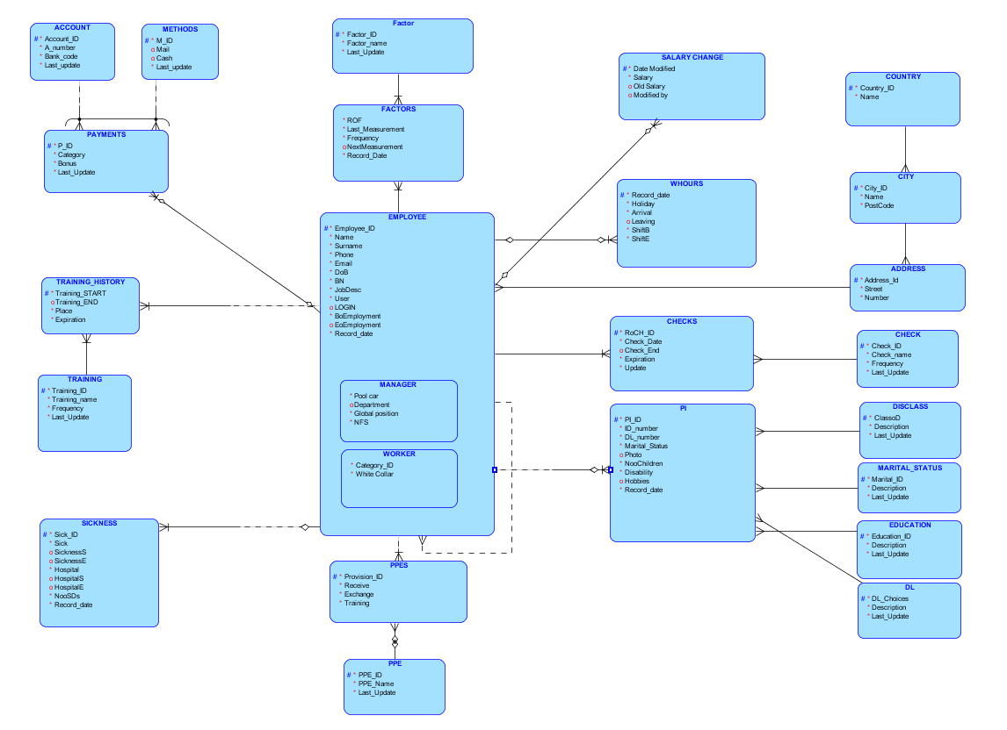

DD S30 L04

Maticový diagram se vztahy, nakreslete pro vaše řešení (stránka 5)

 | EMPLOYEE | PPES | PPE | FACTOR | FACTORS | PAYMENTS | ACCOUNTS | METHODS | TRAINING_HISTORY | TRAINING | SICKNESS | PI | DISCLASS | MARITAL_STATUS | EDUCATION | DL | CHECKS | CHECK | ADDRESS | CITY | COUNTRY | WHOURS | SALARY_CHANGE
EMPLOYEE |  | Given to |  |  |  | Sent to |  |  | Related to |  | Rerated to | Rerated to |  |  |  |  | Rerated to |  | Rerated to |  |  | Related to | Related to
PPES | used by |  | Related to
PPE
FACTOR |  |  |  |  | Connected to
FACTORS | endanger by |  |  | Connected to
PAYMENTS | sent to |  |  |  |  |  | Being sent to | Being sent to
ACCOUNTS |  |  |  |  |  | Sent to
METHODS |  |  |  |  |  | Sent to
TRAINING_HISTORY | related to |  |  |  |  |  |  |  |  | Related to
TRAINING |  |  |  |  |  |  |  |  | Connected to
SICKNESS | undertaken by
PI | connected to |  |  |  |  |  |  |  |  |  |  |  | Connected to
DISCLASS |  |  |  |  |  |  |  |  |  |  |  | Connected to |  | Connected to
MARITAL_STATUS |  |  |  |  |  |  |  |  |  |  |  | Connected to |  |  | Connected to
EDUCATION |  |  |  |  |  |  |  |  |  |  |  | Connected to |  |  |  | Connected to
DL |  |  |  |  |  |  |  |  |  |  |  | Connected to
CHECKS | underwent by |  |  |  |  |  |  |  |  |  |  |  |  |  |  |  |  | Connected to
CHECK |  |  |  |  |  |  |  |  |  |  |  |  |  |  |  |  | Connected to
ADDRESS | belongs to |  |  |  |  |  |  |  |  |  |  |  |  |  |  |  |  |  |  | Connected to
CITY |  |  |  |  |  |  |  |  |  |  |  |  |  |  |  |  |  |  | Connected to |  | Connected to
COUNTRY |  |  |  |  |  |  |  |  |  |  |  |  |  |  |  |  |  |  |  | Connected to
WHOURS | worked by
SALARY_CHANGE | made by

- DD S04 L01

Supertypy a podtypy - definujte minimálně jeden případ supertypu a subtypu ve vašem projektu

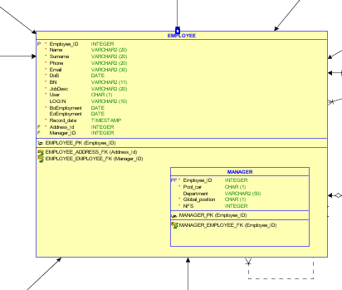
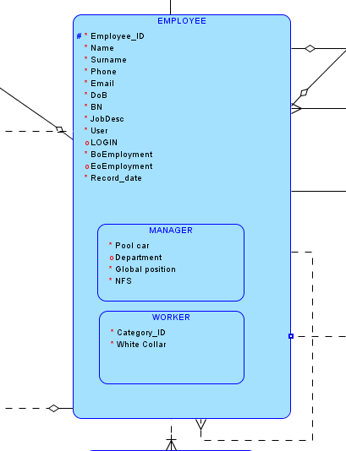

DD S04 L02

Popis obchodních pravidel k vašemu projektu

Table Employee

NAME | TYPE | KEY | MANDATORY | DESCRIPTION | CONSTRAINT
employee_id | INTEGER | YES | YES | Identification number of employee | Primary Key
name | VARCHAR2(20) | NO | YES | First name of employee
surname | VARCHAR2(20) | NO | YES | Surname of employee
phone | VARCHAR2(20) | NO | YES | Phone number
email | VARCHAR2(30) | NO | YES | Email address
dob | DATE | NO | YES | Date of Birth
bn | VARCHAR2(11) | NO | YES | Birth Number
jobdesc | VARCHAR2(20) | NO | YES | Description
"User" | NUMBER | NO | YES | Is an employee USER or NOT?
login | VARCHAR2(10) | NO | NO | Has an employee LOGIN?
boemployment | DATE | NO | YES | Commencement of employment | Boemployment <eoemployment
eoemployment | DATE | NO | NO | End of employment
record_date | TIMESTAMP | NO | YES | Last visit of employee
address_id | INTEGER | YES | YES | ID of employee´s address | Foreign Key
manager_id | INTEGER | YES | NO | ID of employee´s manager | Foreign Key

Table Manager

NAME | TYPE | KEY | MANDATORY | DESCRIPTION | CONSTRAINT
employee_id | INTEGER | YES | YES | Identification number of employee | Primary key
pool_car | NUMBER | NO | YES | Has a manager a pool car?
department | VARCHAR2 | NO | YES | Does a manager lead a department?
global_position | NUMBER | NO | YES | Is it a global position?
nfs | INTEGER | NO | YES | Number of subordinates

Table Worker

NAME | TYPE | KEY | MANDATORY | DESCRIPTION | CONSTRAINT
employee_id | INTEGER | YES | YES | Identification number of employee | Primary key
category_id | INTEGER | NO | YES | Identification number of hygienic category
white_collar | NUMBER | NO | YES | Is an employee white collar or blue collar?

Table PPEs

NAME | TYPE | KEY | MANDATORY | DESCRIPTION | CONSTRAINT
provision_id | INTEGER | YES | YES | Identification number of provision | Primary key
receive | DATE | NO | YES | Date of receive of PPEs
exchange | DATE | NO | YES | Date of exchange of PPEs | Exchange must be >= receive
training | NUMBER | NO | YES | Is an employee trained of the instructions on PPEs?
employee_id | INTEGER | YES | YES | Identification number of employee?
ppe_id | INTEGER | YES | YES | Identification number of PPE | Foreign key

Table PPE

NAME | TYPE | KEY | MANDATORY | DESCRIPTION | CONSTRAINT
ppe_id | INTEGER | YES | YES | Identification number of PPE | Primary key
ppe_name | VARCHAR2(20) | NO | YES | Name of PPE
last_update | TIMESTAMP | NO | YES | Date of last update of the table

Table factors

NAME | TYPE | KEY | MANDATORY | DESCRIPTION | CONSTRAINT
rof | INTEGER | YES | YES | Records in the table | Primary key
last_measurement | DATE | NO | YES | Last measurement of risk factors | Last measurement < nextmeasurement
frequency | INTEGER | NO | YES | Frequency
nextmeasurement | DATE | NO | NO | Next measurement
employee_id | INTEGER | NO | YES | ID of employee
factor_id | INTEGER | YES | YES | ID of risk factor | Foreign key

Table factor

NAME | TYPE | KEY | MANDATORY | DESCRIPTION | CONSTRAINT
factor_id | INTEGER | YES | YES | ID of risk factor | Primary key
factor_name | DATE | NO | YES | Factor´s name
last_update | INTEGER | NO | YES | Date of last update of the table

Table payments

NAME | TYPE | KEY | MANDATORY | DESCRIPTION | CONSTRAINT
p_id | INTEGER | YES | YES | Number of record of the table | Primary key
category | INTEGER | NO | YES | Category
bonus | INTEGER | NO | YES | Monthly bonus
employee_id | INTEGER | NO | YES | ID of employee
m_id | TIMESTAMP | YES | NO | ID of method | Foreign key
account_id | INTEGER | YES | NO | ID of account | Foreign key
last_update | TIMESTAMP | NO | YES | Date of last update of the table

Table methods

NAME | TYPE | KEY | MANDATORY | DESCRIPTION | CONSTRAINT
m_id | INTEGER | YES | YES | ID of method | Primary key
mail | NUMBER | NO | NO | Post
cash | NUMBER | NO | NO | Cash
last_update | TIMESTAMP | NO | YES | Date of last update of the table

Table account

NAME | TYPE | KEY | MANDATORY | DESCRIPTION | CONSTRAINT
account_id | INTEGER | YES | YES | ID of account | Primary key
a_number | NTEGER | NO | YES | Account number
bank_code | INTEGER | NO | YES | Bank code
last_update | TIMESTAMP | NO | YES | Date of last update of the table

Table Training_history

NAME | TYPE | KEY | MANDATORY | DESCRIPTION | CONSTRAINT
employee_id | INTEGER | YES | YES | ID of employee | Primary key
training_start | DATE | NO | YES | Start of training | training_start <= training_end
training_end | DATE | NO | NO | End of training
place | VARCHAR2(50) | NO | YES | The place where training is taken
expiration | DATE | NO | YES | Length of training | training_start < expiration  training_end < expiration
training_id | INTEGER | YES | YES | ID of training | Foreign key

Table Training

NAME | TYPE | KEY | MANDATORY | DESCRIPTION | CONSTRAINT
training_id | INTEGER | YES | YES | ID of employee | Primary key
training_name | VARCHAR2(50 | NO | YES | Start of training
frequency | INTEGER | NO | YES | Periodicity
last_update | TIMESTAMP | NO | YES | Date of last update of the table

Table Sickness

NAME | TYPE | KEY | MANDATORY | DESCRIPTION | CONSTRAINT
sick_id | INTEGER | YES | YES | Identification number of sickness leave | Primary key
sick | NUMBER | NO | YES | Was an employee sick?
sicknesss | DATE | NO | NO | Start of sickness | Sicknesss <= sicknesse
sicknesse | DATE | NO | NO | End of sickness
hospital | NUMBER | NO | YES | Was an employee hospitalized?
hospitals | DATE | NO | NO | Start of sickness | hospitals <= hospitale
hospitale | DATE | NO | NO | End of sickness
noosds | INTEGER | NO | NO | Number of days in hospital
record_date | TIMESTAMP | NO | YES | Date of record
employee_id | INTEGER | YES | YES | Identification number of employee | Foreign key

Table PI

NAME | TYPE | KEY | MANDATORY | DESCRIPTION | CONSTRAINT
pi_id | INTEGER | YES | YES | Identification number of personal record | Primary key
id_number | INTEGER | NO | YES | Number of ID card
dl_number | INTEGER | NO | YES | Number of driving license
marital_status | NUMBER | NO | YES | Option of marital status
photo | BLOB | NO | NO | Photo of employee
noochildren | INTEGER | NO | YES | Number of children
disability | NUMBER | NO | YES | Is employee disabled?
hobbies | VARCHAR2(50), | NO | NO | Hobbies
record_date | TIMESTAMP | NO | YES | Date of record
employee_id | INTEGER | YES | YES | Identification number of employee | Foreign key
classod | INTEGER | YES | YES | Class of disability | Foreign key
marital_id | INTEGER | YES | YES | Identification number of marital status | Foreign key
education_id | INTEGER | YES | YES | Identification number of education | Foreign key
dl_choices | INTEGER | YES | YES | Identification number of driving license | Foreign key

Table "disclass"

NAME | TYPE | KEY | MANDATORY | DESCRIPTION | CONSTRAINT
classod | INTEGER | YES | YES | Identification number of class of disabillity | Primary key
description | VARCHAR2(100) | NO | YES | Description
last_update | TIMESTAMP | NO | YES | Last update of the record

Table marital_status

NAME | TYPE | KEY | MANDATORY | DESCRIPTION | CONSTRAINT
marital_id | INTEGER | YES | YES | Identification number of marital status | Primary key
description | VARCHAR2(50 | NO | YES | Description
last_update | TIMESTAMP | NO | YES | Last update of the record

Table education

NAME | TYPE | KEY | MANDATORY | DESCRIPTION | CONSTRAINT
education_id | INTEGER | YES | YES | Identification number of education | Primary key
description | VARCHAR2(50) | NO | YES | Description
last_update | TIMESTAMP | NO | YES | Last update of the record

Table DL

NAME | TYPE | KEY | MANDATORY | DESCRIPTION | CONSTRAINT
dl_choices | INTEGER | YES | YES | Identification number of choice of driving license | Primary key
description | VARCHAR2(50) | NO | YES | Description
last_update | TIMESTAMP | NO | YES | Last update of the record

Table checks

NAME | TYPE | KEY | MANDATORY | DESCRIPTION | CONSTRAINT
roch_id | INTEGER | YES | YES | Record of checks details | Primary key
check_date | DATE | NO | YES | Date of check
check_end | DATE | NO | NO | End of check | check_end >= check_date
expiration | DATE | NO | YES | Expiration of check
employee_id | INTEGER | YES | YES | Identification number of employee
check_id | INTEGER | YES | YES | Identification number of check | Foreign key
"Update" | DATE | NO | YES | Last update of record

Table "CHECK"

NAME | TYPE | KEY | MANDATORY | DESCRIPTION | CONSTRAINT
check_id | INTEGER | YES | YES | Identification number of check
check_name | VARCHAR2(40) | NO | YES | Name of check
frequency | INTEGER | NO | YES | Periodicity of check
last_update | TIMESTAMP | NO | YES | Last update of the record

Table Address

NAME | TYPE | KEY | MANDATORY | DESCRIPTION | CONSTRAINT
address_id | INTEGER | YES | YES | ID of address | Primary key
city_id | INTEGER | NO | YES | ID of city | Foreign key
street | VARCHAR2(50) | NO | YES | Name of street
"Number" | INTEGER | NO | YES | Street number

Table City

NAME | TYPE | KEY | MANDATORY | DESCRIPTION | CONSTRAINT
city_id | INTEGER | YES | YES | ID of city | Primary key
name | VARCHAR2(50) | NO | YES | Name of city
postcode | INTEGER | NO | YES | Postcode
country_id | INTEGER | NO | YES | ID of country | Foreign key

Table whours

NAME | TYPE | KEY | MANDATORY | DESCRIPTION | CONSTRAINT
record_date | DATE | YES | YES | Date of record | Primary key
holiday | INTEGER | NO | YES | How many days of holiday employee has
arrival | DATE | NO | YES | Begin of shift | arrival < leaving
leaving | DATE | NO | NO | End of shift
shiftb | DATE | NO | YES | Begin of regular shift | Shiftb < shifte
shifte | DATE | NO | YES | End of regular shift
employee_id | INTEGER | YES | YES | Identification number of employee | Foreign key

Table Salary change

NAME | TYPE | KEY | MANDATORY | DESCRIPTION | CONSTRAINT
date_modified | DATE | YES | YES | Date of change | Primary key
salary | INTEGER | NO | YES | Amount of salary
old_salary | INTEGER | NO | NO | Last amount of salary
modified_by | VARCHAR2(50) | NO | NO | Who modified salary
employee_id | INTEGER | YES | YES | ID of employee | Foreign key

DD S05 L01

In the project, there are those relationships:

Name of relation | Type of relation
Employee_Factors | Nontransferable
Factors_Factor | Transferable
Employee_Payments | Nontransferable
Payments_Account | Transferable
Payments_Methods | Transferable
Employee_Training_History | Transferable
Training_History_Training | Nontransferable
Employee_Sickness | Nontransferable
Employee_PPEs | Nontransferable
PPEs_PPE | Transferable
Employee_Manager | Transferable
Employee_PI | Nontransferable
PI_DisClass | Transferable
PI_Marital_Status | Transferable
PI_Education | Transferable
FI_DI | Transferable
Employee_Checks | Nontransferable
Checks_check | Transferable
Employee_address | Transferable
Address_City | Transferable
City_Country | Transferable
Employee_Whours | Nontransferable
Employee_Salary | Nontransferable

DD S05 L03

Mějte ve svém projektu minimálně jednu vazbu M:N bez informace a jednu vazbu M:N s informací

In the project, you can find these types of M:N relations:

Name of relation | Type of relation
Employee_Training_history | 1:N identifying
Training_history_training | 1:N identifying
Employee_Address | M:N relationship

DD S06 L01

Zakomponujte do svého projektu minimálně jednu identifikující vazbu 1:N s tím, že přenesený cizí klíč bude i klíčem v tabulce nové

I have used these 1:N relations identifying.

Name of relation | Type of relation
Employee_Training_history | 1:N identifying
Training_history_training | 1:N identifying
Employee_Whours | 1:N identifying
Employee_Salary | 1:N identifying

DD S06 L02-04

- Mějte své schéma v první normální formě – bez neatomických atributů
- Ve druhé normální formě – bez vazeb na podklíči
- Ve třetí normální formě – bez vazeb mezi sekundárními atributy

- All the tables were designed in the First Norm Form.

- In the project, there these tables in the Second Norm Form.

Table | Type of relation
Employee_Training_history | Second Normal Form
Training_history_training | Second Normal Form
Employee_Whours | Second Normal Form
Employee_Salary | Second Normal Form

- These tables are designed with regard to Third Normal Form.

Name of relation | Type of relation
Employee_Training_history | Third Normal Form
Training_history_training | Third Normal Form
Employee_Whours | Third Normal Form
Employee_Salary | Third Normal Form

DD S07 L01

Vyzkoušejte ve vašem projektu definovat ARC (lze definovat v ORACLE SQL Developeru Data Modeleru)

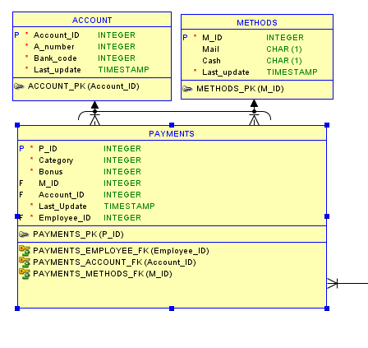

DD S07 L02

Zkuste ve vašem projektu definovat hierarchické a rekurzivní relace

- Hierarchická relace
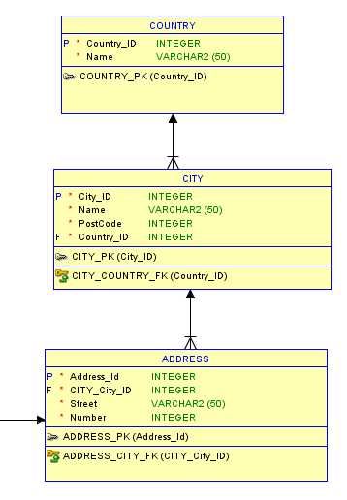

- rekurzivní relace

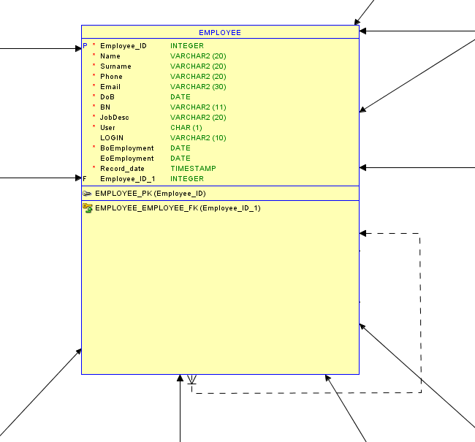

DD S07 L03

Popište, jak ve vašem systému evidujete historická data

In my project, I monitor the changes in these entities with regard to the time the changes were made.

- Payments
- Training_History
- Factors
- WHours

All the tables include an attribute retaining the information on an issue of record in the table.

- DD S09 L01

Demonstrujte na vašem projektu ukládání změn v čase

As an example from my project, I can present the entity WHOURS in which shifts of employees are recorded on a daily basis.

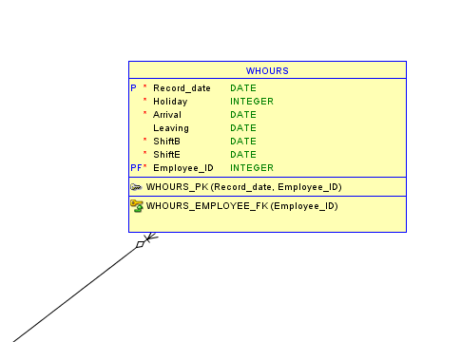

All records made to the entities includes an attribute retaining the information on the date the record was created.

DD S09 L02

These entity was designed to journal attribute Salary and its changes over time.

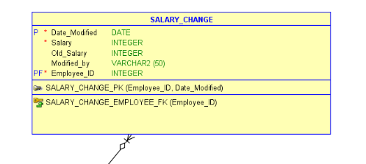
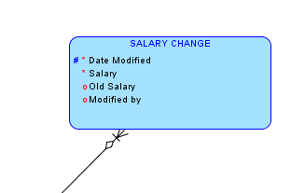

DD S10 L01

Revidujte váš návrh podle konvencí pro čitelnost vašeho schématu

- Large ERD - EMPLOYEE

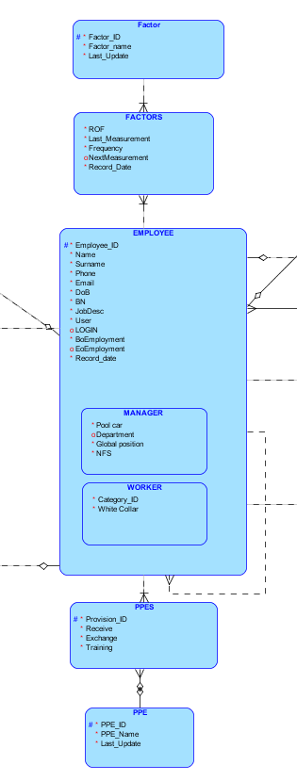

- Sub-Diagram – Relationships among the entity EMPLOYEE and entities Salary Change and WHours

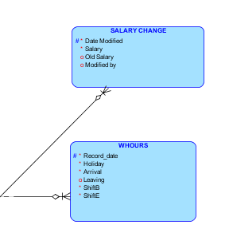

- Sub-Diagram - Relationship between the entity EMPLOYEE and the entitiy SICKNESS

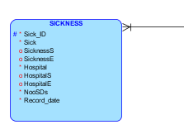
- Sub-Diagram - Relationships among the entity EMPLOYEE and the entities TRAINING_HISTORY and TRAINING

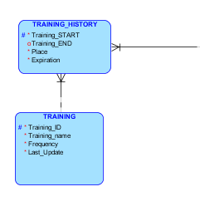
- Sub-Diagram - Relationships among the entity EMPLOYEE and the entities PAYMENTS and ACCOUNT and METHODS

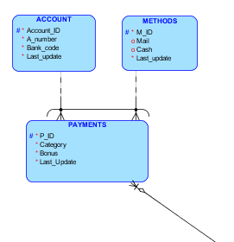
- Sub-Diagram - Relationships among the entity EMPLOYEE and the entities ADDRESS and CITY and COUNTRY

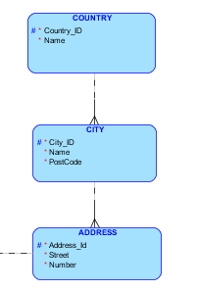

- Sub-Diagram - Relationships among the entity EMPLOYEE and the entities CHECKS and CHECK

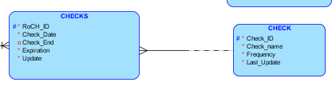

- Sub-Diagram - Relationships among the entity EMPLOYEE and the entities PI and DISCLASS and MARITAL_STATUS,EDUCATION, DL

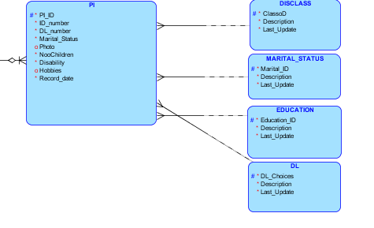

DD S10 L02

Generické modelování - zvažte, případně popište nebo použijte ve svém řešení generický model datových struktur, v čem je tento přístup výhodnější oproti tradičním metodám návrhu datových struktur

DD S11 L01

Popište na vašem projektu příklady integritních omezení pro entity, vazby, atributy a uživatelsky definované integrity

NO. | TABLE | ATTRIBUTE | CONSTRAINT
1. | PPEs | Exchange | Exchange must be >= receive
2. | Factors | Last measurement | Last measurement < nextmeasurement
3. | Training_history | training_start | training_start <= training_end
4. | Training_history | training_start | training_start < expiration
5. | Training_history | training_end | training_end < expiration
6. | Employee | Boemployment | Boemployment <=eoemployment
7. | Sickness | Sicknesss | Sicknesss <= sicknesse
8. | Sickness | hospitals | hospitals <= hospitale
9. | Checks | check_end | check_end >= check_date
10. | Whours | arrival | arrival < leaving
11. | Whours | Shiftb | Shiftb <= shifte

All tables contain primary keys, foreign keys, and attributes which are NOT NULL.

DD S11 L02-04

Generujte relační schéma z vašeho konceptuálního modelu a uvědomte si změny, které ve schématu nastaly a proč

